Virtualization: synonymous with hardware virtualization. “*Customizable computing environments on demand”*

1. Why has virtualization technology gained more attention?

* **Increased performance and computing capacity:**
* **Underutilized hardware and software resources:** 
  + increased performance and computing capacity
  + effect of limited use of resources.
* **Lack of space:**
  + *Server consolidation* is a technique for aggregating multiple services and applications originally deployed on different servers on one physical server. Server consolidation allows us to reduce the power consumption of a data center and resolve hardware underutilization
* **Greening initiatives:**
  + Energy Consumption/ cooling
* **Rise of administrative cost:** 
  + More additional capacity- more administrative cost
  + ***Labor-intensive operations:*** Hardware monitoring, defective hardware replacement, server setup-updates, server resources monitoring and backups.

1. First Virtualization technology: **virtual machine-based programming languages**:

* 1995: Sun released Java. WORA: write once run anywhere:
* 2002 Microsoft released .NET Framework
* 2006 Google Virtual machine model developed

1. What are the characteristics of virtualized environments?

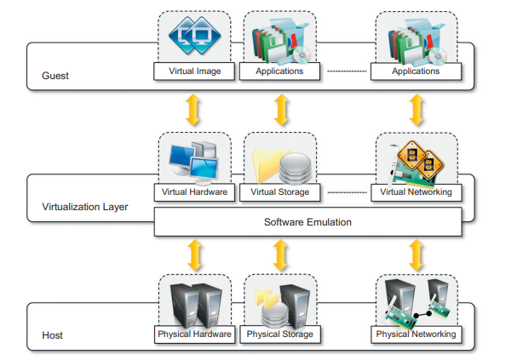

* **Increased security:**
* **Managed Execution:**
  + Sharing- host with multiple guests.
  + Aggregation- distributed computing or cluster management software
  + Emulation- testing purposes
  + Isolation- self described
  + Performance Tuning- control of resources: providing QoS, virtual machine migration
* **Portability**: virtual image, JVM,

1. Taxonomy of Virtualization Techniques:

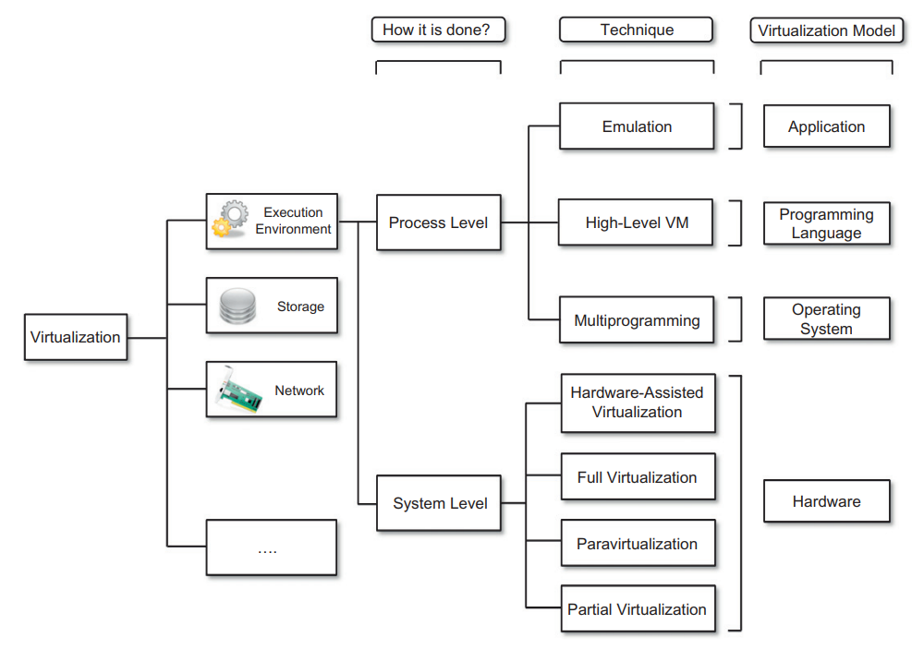

* Machine Reference Model:
* Hardware-level virtualization
  + Hardware assisted virtualization
    - Full Virtualization
    - Paravirtualization
    - Partial virtualization
  + Operating system-level virtualization
* Programming language-level Virtualization
* Application-level virtualization

1. Pros and cons of Virtualization:

* Virtualization advantages:
  + Sandbox
  + All characteristics
* Virtualization Disadvantages:
  + Performance degradation
  + Inefficiency and degraded user experience
  + Security holes and new threats